|  |  |  |
| --- | --- | --- |
| **Problem Chosen** E | **2022 MCM/ICM Summary Sheet** | **Team Control Number** 2213398 |

**Harvest or not? Let’s decide scientifically!**

**Summary**

Forests can control atmospheric carbon levels in many ways thus people need to utilize and manage forests well, especially faced with today's global warming threat. Since a one-size-fits-all approach clearly cannot maximize the value of diverse forests, it’s an essential issue for us to know how to obtain the carbon sequestration potential of a particular forest object and then formulate targeted optimal guidance comprehensively and scientifically.

First, we establish **Carbon Sequestration Model** to obtain the total result of carbon sequestration. Considering influencing factors, this model includes **two core formulas** -- "carbon sequestration amount - tree age formula" and "optimal number of trees of each age - tree age formula". The final result balances the two carbon storage methods of forest products and forest retention thus determines the most effective way at carbon sequestration.

Next, considering that the value of forests is not only carbon sequestration, we begin with **improving the spectrum** for the improvement of forest management plan, adding "potential carbon sequestration, conservation and biodiversity aspects, recreational uses, and cultural considerations". At the same time, we **determine the corresponding conditions** that ",,,,, trees should be uncut".

After clarifying the scope and harvest conditions, we made **Forest Management Decision Model**. It integrates various forest values and thus leads to a more comprehensive optimal plan for forest management. It is worth noting that there is always **a transition point** when the two management plans are implemented, and we find that generally this transition point can be effectively determined by the ",,," parameters of the forest.

Then, we apply the above two models to various forests, including **",,,, selected forest name"**.完全不砍100年的总固定量是、、、，整体发展得分是、、、。三种砍树情况下的总固定量及发展得分分别是、、、。我们在后三种情况下继续优化，从而确保了合理性且是最佳的 thus verify the rationality of our plan. Our conclusion is:将什么类型的树木或者什么年龄的树木砍掉或者最终保持到什么样的状态，比保持不刊更有利于这个森林整理发展. 在砍树政策实施的条件下，将最有利于、、、森林的整理发展，且多少含量的 carbon would be sequestered by the forest and its products over 100 years, which is (是不实行的多少倍) total amount without harvest.

In addition, to ensure a smooth transition from the existing management schedule to the new one, we not only discuss **a targeted strategy** that is relevant to anyone related, but also write a two-page **non-technical newspaper article** to convince the local community.

Finally, we carry out **a sensitivity analysis of the \\\ model** and **an error analysis of the \\\\ model**, demonstrating the robustness and accuracy of our models. We also evaluate the advantages and disadvantages of our models, hoping to continue to extend them in the future.

**Keywords:** Forest Management; Sustainable Development; Carbon Sequestration Model; Forest Management Decision Model; ……. Forest

Table of Contents

1 Introduction 3

1.1 Problem Background 3

1.2 Restatement of the Problem 3

1.3 Our Work(要添加校对) 4

2 Assumptions and Justifications 5

3 Notations and Deﬁnitions 6

3.1 Notations 6

3.2 Definitions 6

4 The name of model 1 6

4.1 Data Description 6

4.2 The Establishment of Model 1 6

4.3 The Solution of Model 1 7

5 The name of model 2 7

6 The name of model 3 7

7 Sensitivity Analysis 7

8 Model Evaluation and Further Discussion 7

8.1 Strengths 7

8.2 Weaknesses 7

8.3 Further Discussion 8

9 Conclusion 8

References 9

Appendices 10

# Introduction

## Problem Background

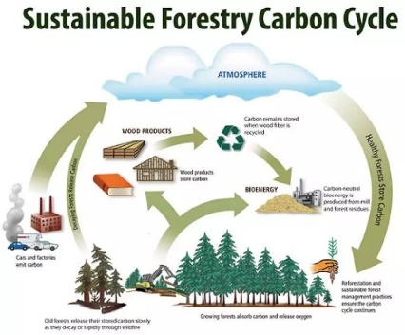*“Nature is a loving mother, but also a butcher in cold blood”,* Victor Hugo once said. At present, global warming has become a massive threat faced by countries all around the world. In order to control atmospheric temperature, promote sustainable economic and ecological development, people need to take effective measures to reduce greenhouse gases in the atmosphere. It is not only related to reducing emissions, but can also be achieved by enhancing carbon sequestration.

Due to the natural photosynthesis of green plants, it can be used for carbon sequestration. It is an effective, environmentally friendly and economical way. Therefore, how much carbon dioxide forests and their products can be expected to sequester over time is the primary issue in determining how to manage forests well. At the same time, because forests are not only for carbon storage, people must also find a balance between the other values of forests and the value of carbon sequestration. Considering the various values of forests will not only provide best solutions for forest managers, but also provide correct directions for our greener and more environmentally-friendly future.

## Restatement of the Problem

Forests, and the products they produce, are crucial to repairing our world’s climate and creating a low carbon future. Given the background information and constraints identified in the problem statement, we need to solve the following problems:

* Develop a carbon sequestration calculation model to determine the total amount of carbon dioxide that can be sequestered by forests and their products, and then determine how to balance harvesting values and sequestering values as living trees for a most effective carbon sequestration plan.
* Develop a decision-making model for a comprehensive forest management plan. It is necessary to clarify the management scope of the decision-making model, consider the situation that the forest should not be cut down, figure whether there is a transition point between the implementation of the two management plans and how to determine the point, based on the characteristics or location of the forest.
* Apply the model to a variety of forests and identify a forest that would suggest the inclusion of harvesting in its management plan. It needs to indicate how much carbon dioxide the forest and its products would sequester over a 100-year period, and justify the decision-making model to develop a forest management plan.
* Supposing that best management plan logging intervals that are 10 years longer than current practices. Discuss a strategy that is relevant to forest managers and all who use the forest to convert the existing schedule to the new one.
* Write a one- to two-page non-technical newspaper article to explain the rationale of the proposed forest management plan given by the models. The explanation should be clear and explicit enough to convince the local community that this is the best decision for them.

## Our Work(要添加校对)

1. We develop a carbon sequestration model to obtain the total result of carbon sequestration. Considering influencing factors, this model includes two core formulas -- "carbon sequestration amount-tree age formula" and "optimal number of trees of each age-tree age formula". The result balances the two carbon storage methods of forest products and forest retention, and can determines what forest management plan is most effective at sequestering carbon dioxide.
2. Considering that the value of forests is not only carbon sequestration, we improve the spectrum for the improvement of forest management plan, adding "potential carbon sequestration, conservation and biodiversity aspects, recreational uses, and cultural considerations". At the same time, we determine the corresponding conditions that ",,,,, trees should be uncut".
3. We make a decision model after clarifying the scope and harvest conditions. This model integrates various forest values and thus leads to a more comprehensive optimal plan for forest management. It is worth noting that there is always a transition point when the two management plans are implemented, and we find that generally this transition point can be effectively determined by the ",,,,,," parameters of the forest.
4. We apply the above two models to various forests to obtain their corresponding recommended management plans. Based on our models, the future management of ",,,, selected forest name" should be harvested to produce a product. We calculate its total carbon sequestration amount of the forest and its products over 100 years. Compared with the total amount without harvesting trees, we thus verify the rationality of our plan.
5. We also discuss a strategy that is relevant to forest managers and all who use the forest to achieve a good transition from the existing management schedule to the new one. Based on the assumptions given, the best management plan's logging interval is 10 years longer than current management practices.
6. We write a two-page non-technical newspaper article to justify our analysis to convince the local community that harvesting would be more beneficial for carbon sequestration and a long-term development.

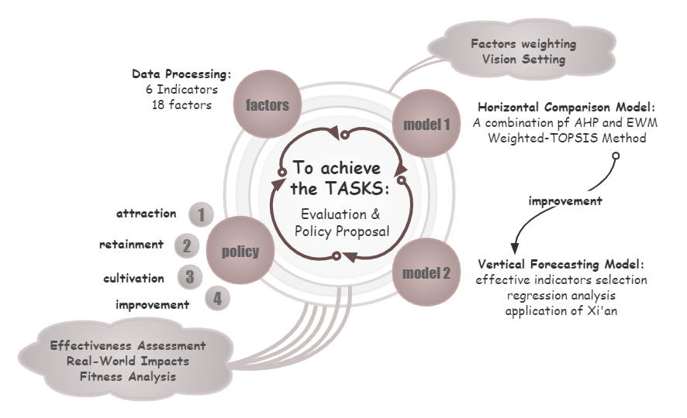

# Assumptions and Justifications

* **Deforestation is made into long-term products that more carbon can be sequestered than existing practices, rather than products that used quickly.**

Since we are advising forest managers, we do not consider too many economic and commercial considerations.

* **The ways of harvesting do not bring about extra carbon release.**

Logging operations are related to various uncertainties such as means of transportation, logging techniques, logging time and so on, which are difficult to take into account. Also, in the process of harvesting or transportation, the carbon dioxide emissions are far less than the carbon sequestration in wood. Therefore, it can be ignored in our analysis.

* **The carbon release from fossil energy retained in the soil after tree felling is not considered in the model.**

Carbon sequestration occurs in above-ground biomass and below-ground soils, and felling trees releases carbon into soils. They should have been considered in continuous biomass production, but we do not take account of them in our calculations for analysis simplification.

* 砍伐都是制成比现有保持为森林固碳更多的产品，而不是快捷使用的产品

由于我们是为森林管理者提供建议支持，所以并没有考虑过多的经济效益和商品因素。

* 砍伐行为本身并不会带来碳释放

砍伐操作和运输工具、砍伐技术、砍伐时间的等多种不确定性因素相关，所以难以计入考量。且在采伐、运输和使用过程中，排放的二氧化碳也远远少于木材中的固碳量。所以在我们的模型计算中忽略不计（最后分析缺点的时候也提到）

* 砍伐树木后土壤中留存的化石能源的碳的释放量不参与模型中考虑。

虽然碳封存发生在地上生长的生物量和地下土壤中，砍伐树木向土壤释放碳，这本应该被纳入了连续的生物量生产中，但是为了简化分析，我们在使用模型计算时不考虑这一影响。

# Notations and Deﬁnitions

## Notations

The key mathematical notations used in this paper are listed in Table 1.

Table 1: Notations used in this paper

|  |  |  |
| --- | --- | --- |
| **Symbol** | **Description** | **Unit** |
|  |  |  |

## Definitions

* **Harvesting (trees):** the process of cutting down trees to be used as forest products.
* **Forest Management:** the process of managing a forest to include determining what trees should be cut down, which trees should be left standing, a timeline for harvesting the trees, and how to regenerate the forest.

# The name of model 1

这个大的部分主要介绍论文中第一个模型的建立和求解，第一个模型往往用来解决题目问的第一个问题。这个模型的标题需要结合你的题目或论文内容进行调整，我这里给的是一个通用的名称。

## Data Description

如果自己收集了数据或者题目给了数据的话，可以先对数据进行一个描述，一般将数据可视化，然后再从图形中得到一些直观的结论。进行数据预处理和数据可视化分析。这部分也不是必须的。

## The Establishment of Model 1

这里可以写第一个模型的建立，模型建立是将原问题抽象成用数学语言的表达式，它一定是在先前的问题分析和模型假设的基础上得来的。因为比赛时间很紧，大多时候我们都是使用别人已经建立好的模型。这部分一定要将题目问的问题和模型紧密结合起来，切忌随意套用模型。我们还可以对已有模型的某一方面进行改进或者优化，或者建立不同的模型解决同一个问题，这样就是论文的创新和亮点。

如果需要用公式的话，可以复制下面这个隐藏的表格，并粘贴到你需要的地方，这个公式的编号会同步更新。

|  |  |
| --- | --- |
| 这里插入公式 | () |

## The Solution of Model 1

这里可以写第一个模型的求解，把实际问题归结为一定的数学模型后，就要利用数学模型求解所提出的实际问题了。一般需要借助计算机软件进行求解，例如常用的软件有Matlab, Spss, Lingo, Excel, Stata, Python等。求解完成后，得到的求解结果应该规范准确并且醒目，若求解结果过长，最好编入附录里。（注意：如果使用智能优化算法或者数值计算方法求解的话，需要简要阐明算法的计算步骤）

同样的，很少有论文直接用“模型求解”作为这部分的标题，大家可以根据得到的结论来合理设计这里的标题。

另外，很多美赛论文对于模型的建立和求解没有区分开，我这里沿用的是类似于国赛的形式，这样可以让论文框架清晰点。

# The name of model 2

# The name of model 3

注意：大多数美赛优秀论文都是对每个问题或者每个模型作为一个一级标题

# Sensitivity Analysis

模型的分析 ：在建模比赛中模型分析主要有两种，一个是灵敏度(性)分析，另一个是误差分析。灵敏度分析是研究与分析一个系统（或模型）的状态或输出变化对系统参数或周围条件变化的敏感程度的方法。

其通用的步骤是：控制其他参数不变的情况下，改变模型中某个重要参数的值，然后观察模型的结果的变化情况。误差分析是指分析模型中的误差来源，或者估算模型中存在的误差，一般用于预测问题或者数值计算类问题。

在美赛的写作中，写的最多的就是灵敏度分析（Sensitivity Analysis），因此这里我们的标题就直接取得是灵敏度分析；如果你既要写灵敏度分析，又要写误差分析（Error Analysis），那么你可以把标题改成： Sensitivity Analysis and Error Analysis

# Model Evaluation and Further Discussion

注：本部分的标题需要根据你的内容进行调整，例如：如果你没有写进一步讨论的话，就直接把标题写成模型的评价。（优缺点一定要写）

## Strengths

这里写论文或者模型的优点

## Weaknesses

这里写缺点：缺点写的个数一般要比优点少

## Further Discussion

进行进一步的讨论，这里可以写模型的改进和拓展：

模型的改进：主要是针对模型中缺点有哪些可以改进的地方；

模型的拓展：将原题的要求进行扩展，进一步讨论模型的实用性和可行性。

# Conclusion

结论部分，这个部分在国赛论文很少见到，但在美赛中出现的频率很高。

这个部分可以是论文中心思想的重申、研究结果或主要观点的归纳，也可以是某些启示性的解释或考虑。

有些论文把“Model Evaluation and Further Discussion”的内容放到了结论部分，这也是可以的，大家可以灵活调整。

# References

参考文献：所有引用他人或公开资料(包括网上资料)的成果必须按照科技论文的规范列出参考文献，并在正文引用处予以标注。

一般新起一页列出参考文献，如果上一个部分的下面有很多空白，那么就不用新起一页了。

美赛中不要出现中文，如果引用中文文献请翻译过来。

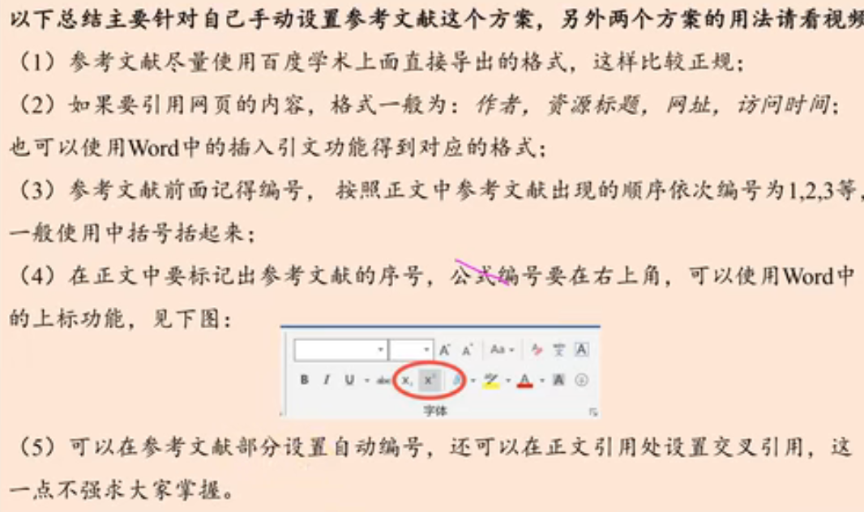

# Appendices

|  |
| --- |
| Appendix 1 |
| Introduce: 这里放上附录1的介绍 |
|  |

|  |
| --- |
| Appendix 2 |
| Introduce: 这里放上附录2的介绍 |
|  |

本部分是附录部分，美赛对于附录不是特别看重，今年还限制了论文的页数（从第二页开始编号，不能超过25页）。

一般新起一页列出附录。

在不超过页数限制的条件下，附录中可以包括下面内容：

* 你们写的代码；
* 某一问题的详细证明或求解过程；
* 自己在网上找到的数据；
* 比较大的流程图；
* 较繁杂的图表或计算结果。